**Zypro interview assignment**

This is the screen layout. The top 4 text boxes are for customizing the application – not a part of an actual form. The application can point to a certain database and table; also, the page row and cache size can be customized. The cache size for the assignment was 100,000 records, but that is a bit large for in-app memory. The default here is 10,000 records (the size displayed is actually half the full cache size allocated – since there are two buffers to facilitate asynchronous threading (anticipating cache replenishment).

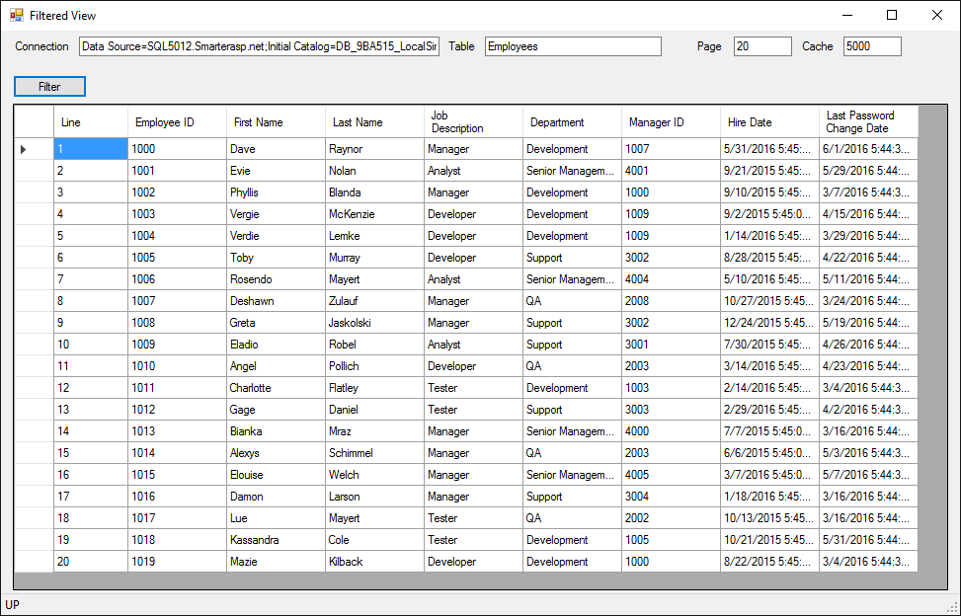

The column headers are click-able for setting filters on each column. If a filter is set on any column, the header text is displayed in bold italic typeface (see ‘First Name’ column below). All filters are applied when the ‘Filter’ button is clicked. Also, any changes to the top row text boxes are applied when the ‘Filter’ button is clicked (even if no filters are applied).

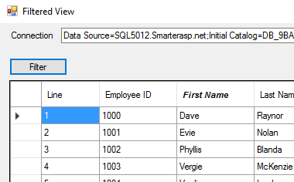

Below is the filter entry pop-up dialog. The second condition is optional and can only be applied if the first condition is entered. Second condition can be And/Or.

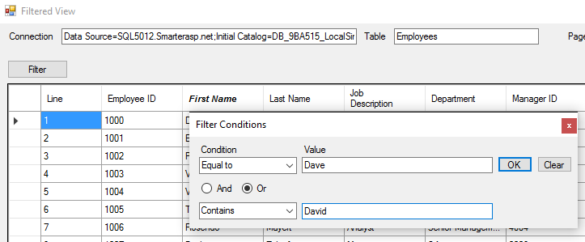

**Scrolling:**

For this assignment, I used only arrow up/down and page up/down for moving through the records. The row data is held in an initial cache, but when scrolling to within 25% of the top or bottom of the held cached records, a separate thread is launched to replenish the next set of cached data from the database to help insure seamless movement between cache boundaries.

**Data Grid:**

I have used a DataGridView control from WinForms. I used VirtualMode here to avoid direct data binding and allow the custom large-dataset scrolling features. In a real-life application, I would also include a scroll bar or paging bar for better conformation with UI expectations and allow quick jumps within the full dataset.